

Observational Report LAB 4: TCP/IP attack lab

ACS 545| Cryptography and Network Security

February 7, 2024

Ashutosh Mishra

Professor: ZesHeng Chen

* Observation Criteria: -

Note: -

1. Used Ubuntu Seed (v20.04 Focal) on Google Cloud Platform
2. Used Real VNC Viewer to perform the actions on GUI
3. All actions are being performed under username - **seed**

* Environment Setup: -

A folder named Crypto was created and the Labsetup file was downloaded from the Seed Documentation site. Post unzipping the folder we find a docker-compose.yml file which contains the configurations for three machines that are connected to the same LAN. The three machines are: -

1. seed - attacker
2. user1 (10.9.0.6)
3. user2 (10.9.0.7)
4. victim (10.9.0.5)

To create the three containers using the .yml file, firstly one can use either **docker-compose build** or **dcbuild** (alias).

As per the attached image, we find that the steps are being skipped. The reason for this is because the containers have already been created. Now we will use either the **docker-compose up** or **dcup** (alias) to start the containers.

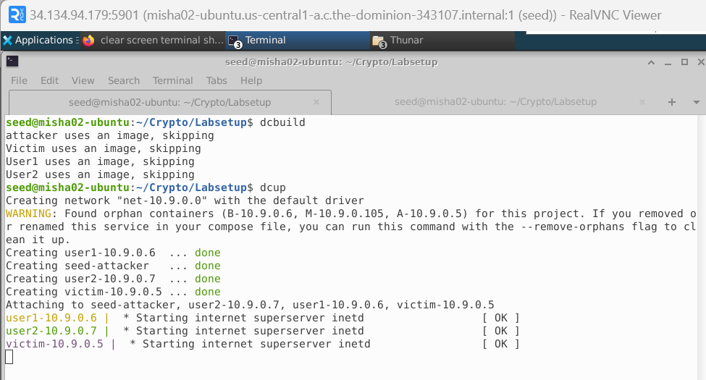

Now, as per the above screenshot, we can see that the containers are up. However, just to cross check we can use either **docker ps –format “{{.ID}} {{.Names}}”** or **dockps** (alias) to show the status of the containers.

* Task 1 (SYN Flooding Attack): -
  + Task 1 A (Launching the Attack using Python): -

For the first task, I have referenced the code shared in class. In this script there is a very small change as per the asked question. The requirement is to send out TCP SYN packets, with randomly generated source IP address, source port and sequence number. So, I have added the TODO fields.

Logging into victim and attacker machines

(Victim)

(Attacker)

Launching Attack

As we can see from below screenshot that initially when tcp_max_syn_backlog was kept at default, the attack was not successful.

However, when the value was set to 64, the attack was successful.

* + Task 1 B (Launch the Attack Using C): -

For part B task, I have reused the same C code provided in class. Below is a screenshot of the code file. The task is the same as that mentioned in Task 1 A.

Running the code: -

As we can see that the connection got disconnected, the attack was successful.

* + Task 1 C (Enable the SYN Cookie Counter Measure): -

For part C task, we needed to enable sync cookies and run both the C and Python code to see if the attacks were successful. As the sync cookies were turned on, the attack never killed the user’s Telnet session hence resulting in a failure.

Tweaking the Sync Flag

Running the attack with C code and monitoring outputs

Using the Python Script

* Task 2 (TCP RST Attacks on telnet Connections): -

For the second task, I have referenced the code shared in class and modified as shown below.

Code Snippet

Wireshark screenshot for output

Output of Session being killed due to code execution

* Task 3 (TCP Session Hijacking): -

For this task the code snippet is as below:-

Starting nc and launching attack

As we can see the message in nc, the attack was successful.

* Task 4 (Creating Reverse Shell using TCP Session Hijacking): -

This task is like Task 3. The only change is in the data field.

Code Snippet: -

Wireshark details to fill the values.

Starting nc

Running the script in Attacker Machine

Attack was successful and Telnet Session had crashed.

* Conclusion: -

The overall experience was exciting. I will be going deeper into the subject and try to discover new ways to handle how we had practiced in lab. Having a base knowledge of how TCP/IP Attacks work, I will like to do a deep dive in this subject to find out more about how to protect the target machines from attacks that occur in a simple manner.